**SUKKUR IBA UNIVERSITY**



# LAB 02

**Assembly language**

**SUBMITTED BY: Abdul Samad**

# CMS: 023-19-0128

# 

**SUBMITTED TO: Sir Riaz**

1. Write an assembly language program that asks the user to input a letter in uppercase. Then, the program should convert that letter to lowercase and print it

**CODE**

.MODEL SMALL

.STACK 256

.DATA

MSG1 DB 'ENTER A UPPER CASE LETTER $'

MSG2 DB 'THE LOWER CASE $'

.CODE

MAIN PROC

MOV AX,@DATA

MOV DS,AX

LEA DX,MSG1

MOV AH,9

INT 21H

MOV AH,1

INT 21H

MOV BL,AL

ADD BL,32

MOV AH, 2 ;ASCII code of carriage return

INT 21H

MOV DL, 10 ;ASCII code of line feed

INT 21H

MOV DL,13

INT 21H

LEA DX,MSG2

MOV AH,9

INT 21H

MOV AH,2

MOV DL,BL

INT 21H

MOV AH,4CH

INT 21H

MAIN ENDP

END

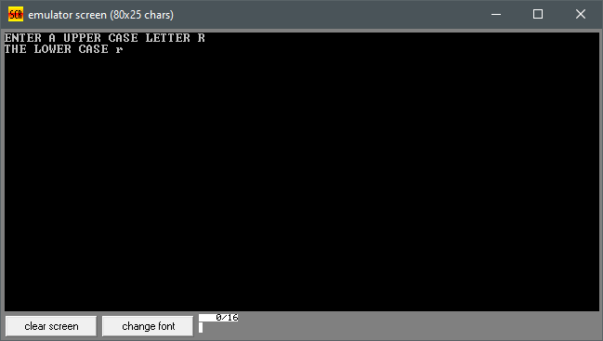

1. Write an assembly language program that asks the user to input a letter in lowercase. Then, the program should convert that letter to uppercase and print it

CODE

.MODEL SMALL

.STACK 256

.DATA

MSG1 DB 'ENTER A Lower CASE LETTER $'

MSG2 DB 'THE LOWER CASE $'

.CODE

MAIN PROC

MOV AX,@DATA

MOV DS,AX

LEA DX,MSG1

MOV AH,9

INT 21H

MOV AH,1

INT 21H

MOV BL,AL

SUB BL,32

MOV AH, 2 ;ASCII code of carriage return

INT 21H

MOV DL, 10 ;ASCII code of line feed

INT 21H

MOV DL,13

INT 21H

LEA DX,MSG2

MOV AH,9

INT 21H

MOV AH,2

MOV DL,BL

INT 21H

MOV AH,4CH

INT 21H

MAIN ENDP

END

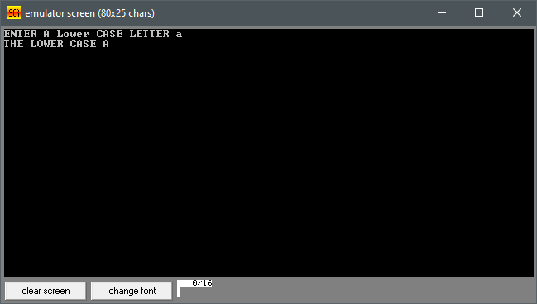

1. Write an assembly language program that asks the user to input two numbers with respective prompt messages and then prints their sum/addition

**CODE**

.MODEL SMALL

.STACK 256

.DATA

MSG1 DB 'ENTER FIRST NUMBER $'

MSG2 DB 'ENTER SECOND NUMBER $'

MSG3 DB 'THE SUM OF TWO NUMBER $'

.CODE

MAIN PROC

MOV AX,@DATA

MOV DS,AX

LEA DX,MSG1

MOV AH,9

INT 21H

MOV AH,1

INT 21H

MOV BL,AL

MOV AH, 2 ;ASCII code of carriage return

INT 21H

mov dl,13

int 21h

MOV DL, 10 ;ASCII code of line feed

INT 21H

MOV DL,13

INT 21H

LEA DX,MSG2

MOV AH,9

INT 21H

MOV AH,1

INT 21H

ADD BL,AL

SUB BL,48

MOV AH, 2

int 21h

mov dl,13

int 21h

MOV DL, 10 ;ASCII code of line feed

INT 21H

LEA DX,MSG3

MOV AH,9

INT 21H

MOV AH,2

MOV DL,BL

INT 21H

MOV AH,4CH

INT 21H

MAIN ENDP

END

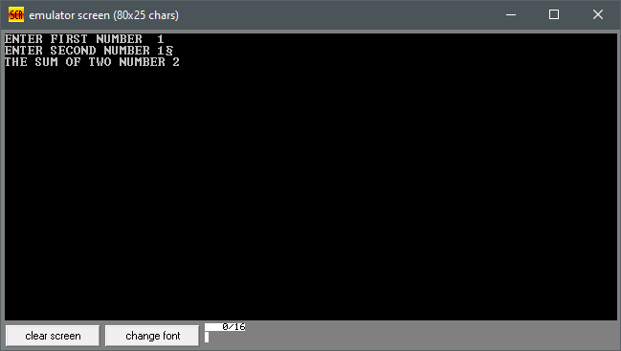

1. Write an assembly language program that asks the user to input two numbers with respective prompt messages and then prints their difference/subtraction

CODE

.MODEL SMALL

.STACK 256

.DATA

MSG1 DB 'ENTER FIRST NUMBER $'

MSG2 DB 'ENTER SECOND NUMBER $'

MSG3 DB 'THE SUb OF TWO NUMBER $'

.CODE

MAIN PROC

MOV AX,@DATA

MOV DS,AX

LEA DX,MSG1

MOV AH,9

INT 21H

MOV AH,1

INT 21H

MOV BL,AL

MOV AH, 2

;ASCII code of carriage return

INT 21H

MOV DL, 10 ;ASCII code of line feed

INT 21H

MOV DL,13

INT 21H

LEA DX,MSG2

MOV AH,9

INT 21H

MOV AH,1

INT 21H

SUB BL,AL

ADD BL,48

MOV AH, 2

mov dl,13

int 21h ;ASCII code of carriage return

MOV DL, 10 ;ASCII code of line feed

INT 21H

LEA DX,MSG3

MOV AH,9

INT 21H

MOV AH,2

MOV DL,BL

INT 21H

MOV AH,4CH

INT 21H

MAIN ENDP

END

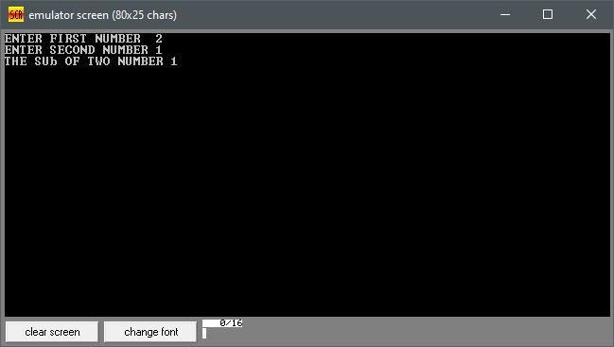

1. Write an assembly language program that asks the user to input two numbers with respective prompt messages. Then, the program should swap/exchange their values and print them

**CODE**

.MODEL SMALL

.STACK 100

.DATA

MSG1 DB 'ENTER FIRST NUMBER$'

MSG2 DB 'ENTER SECOND NUMBER$'

MSG3 DB 'AFTER SWIP $'

MSG4 DB 'ENTER FIRST NUMBER$'

MSG5 DB 'ENTER SECOND NUMBER$'

.CODE

MAIN PROC

MOV AX,@DATA

MOV DS,AX

LEA DX,MSG1

MOV AH,9 ;Code for standard out (display)

INT 21H

MOV AH,1

INT 21H

MOV BL,AL

MOV AH, 2 ;ASCII code of carriage return

MOV DL, 10 ;ASCII code of line feed

INT 21H

MOV DL,13

INT 21H

MOV DL,13

INT 21H

LEA DX,MSG2

MOV AH,9

INT 21H

MOV AH,1

INT 21H

MOV CL,AL

MOV AH, 2 ;ASCII code of carriage return

MOV DL, 10 ;ASCII code of line feed

INT 21H

MOV DL,13

INT 21H

MOV DL,13

INT 21H

LEA DX,MSG3

MOV AH,9

INT 21H

MOV AH, 2 ;ASCII code of carriage return

MOV DL, 10 ;ASCII code of line feed

INT 21H

MOV DL,13

INT 21H

LEA DX,MSG4

MOV AH,9

INT 21H

mov ah,2

MOV DL,cl

INT 21H

MOV AH, 2 ;ASCII code of carriage return

MOV DL, 10 ;ASCII code of line feed

INT 21H

MOV DL,13

INT 21H

LEA DX,MSG5

MOV AH,9

INT 21H

mov ah,2

MOV DL,bl

INT 21H

MAIN ENDP

END

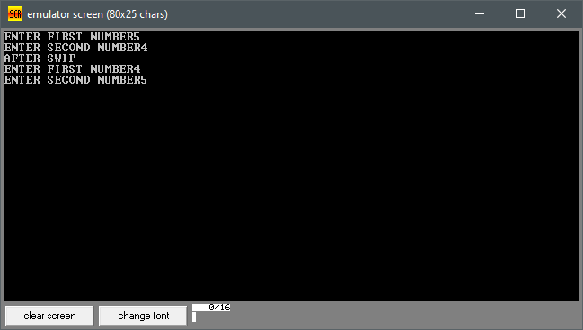

1. Write an assembly language program that displays the pyramid made of asterisks, as shown below:

**CODE**

.model small

.stack 100h

.data

var5 db '*****$'

var4 db '****$'

var3 db '***$'

var2 db '**$'

var1 db '*$'

.code

main proc

mov ax, @data

mov ds, ax

mov ah, 09

lea dx, var5

int 21h

mov ah, 02

mov dl,13

int 21h

mov dl, 10

int 21h

mov ah, 09

lea dx, var4

int 21h

mov ah, 02

mov dl,13

int 21h

mov dl, 10

int 21h

mov ah, 09

lea dx, var3

int 21h

mov ah, 02

mov dl,13

int 21h

mov dl, 10

int 21h

mov ah, 09

lea dx, var2

int 21h

mov ah, 02

mov dl,13

int 21h

mov dl, 10

int 21h

mov ah, 09

lea dx, var1

int 21h

mov ah, 4ch

int 21h

main endp

end main

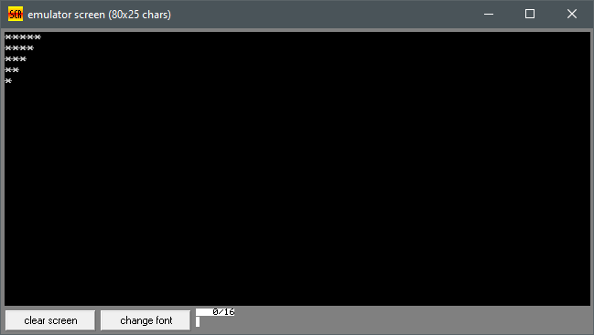

1. Write an assembly language program that displays the following output:

**CODE**

.model small

.stack 100h

.data

var5 db '12345$'

var4 db '1234$'

var3 db '123$'

var2 db '12$'

var1 db '1$'

.code

main proc

mov ax, @data

mov ds, ax

mov ah, 09

lea dx, var1

int 21h

mov ah, 02

mov dl,13

int 21h

mov dl, 10

int 21h

mov ah, 09

lea dx, var1

int 21h

mov ah, 02

mov dl,13

int 21h

mov dl, 10

int 21h

mov ah, 09

lea dx, var3

int 21h

mov ah, 02

mov dl,13

int 21h

mov dl, 10

int 21h

mov ah, 09

lea dx, var4

int 21h

mov ah, 02

mov dl,13

int 21h

mov dl, 10

int 21h

mov ah, 09

lea dx, var5

int 21h

mov ah, 4ch

int 21h

main endp

end main

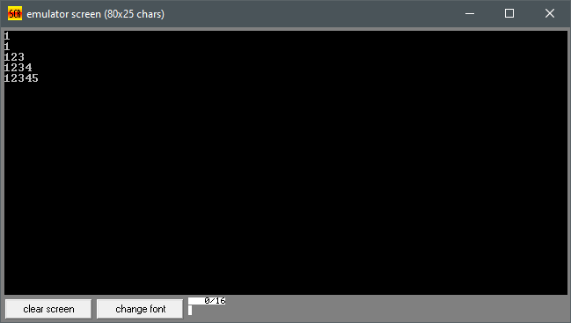

1. Write a program to (a) prompt the user, (b) read first, middle, and last initials of a person's name, and (c) display them down the left margin.

**CODE**

.Model Small

.Stack 100h

.data

var1 db "Enter Three Initials$"

var2 db ' '

.code

Main Proc

Mov ax,@data

Mov ds,ax

Mov ah,09

lea dx, var1

Int 21h

Mov ah,01

int 21h

Mov bl,al

Mov ah,01

Int 21h

Mov cl,al

Mov ah,01

Int 21h

Mov var2,al

Mov ah,02

mov dl,13

int 21h

Mov dl,10

Int 21h

Mov ah,02

Mov dl,bl

Int 21h

Mov ah,02

mov dl,13

int 21h

Mov dl,10

Int 21h

Mov ah,02

Mov dl,cl

Int 21h

Mov ah,02

mov dl,13

int 21h

Mov dl,10

Int 21h

Mov ah,02

Mov dl,var2

Int 21h

Mov ah,04ch

Int 21h

Main Endp

End Main

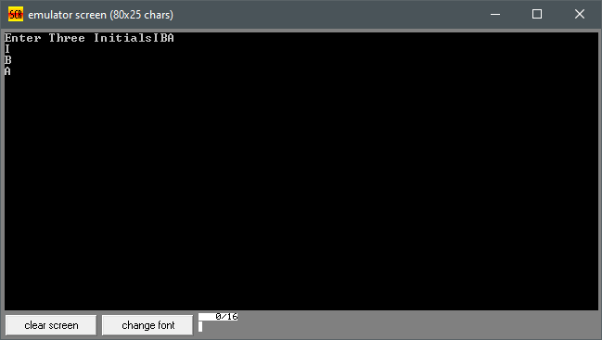

1. Write a program to display a 4 x 10 solid box of asterisks (4 rows and 10 columns), as

**CODE**

.model small

.stack 100h

.data

var db '**********$'

.code

main proc

mov ax, @data

mov ds, ax

mov ah, 09

lea dx, var

int 21h

mov ah, 02

mov dl,13

int 21h

mov dl, 10

int 21h

mov ah, 09

lea dx, var

int 21h

mov ah, 02

mov dl,13

int 21h

mov dl, 10

int 21h

mov ah, 09

lea dx, var

int 21h

mov ah, 02

mov dl,13

int 21h

mov dl, 10

int 21h

mov ah, 09

lea dx, var

int 21h

mov ah, 02

mov dl,13

int 21h

mov dl, 10

int 21h

mov ah, 09

lea dx, var

int 21h

mov ah, 02

mov dl,13

int 21h

mov dl, 10

int 21h

mov ah, 09

lea dx, var

int 21h

mov ah, 02

mov dl,13

int 21h

mov dl, 10

int 21h

mov ah, 09

lea dx, var

int 21h

mov ah, 02

mov dl,13

int 21h

mov dl, 10

int 21h

mov ah, 09

lea dx, var

int 21h

mov ah, 02

mov dl,13

int 21h

mov dl, 10

int 21h

mov ah, 09

lea dx, var

int 21h

mov ah, 02

mov dl,13

int 21h

mov dl, 10

int 21h

mov ah, 09

lea dx, var

int 21h

mov ah, 4ch

int 21h

main endp

end main

